FOR IMMEDIATE RELEASE:

Women Under Siege: It’s Happening Right Here
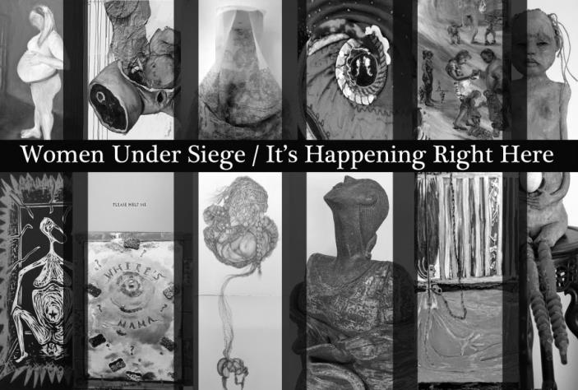
Curated by Susan Grabel

January 3-28, 2017

Opening reception:
Thursday January 5, 2017
6-8 pm

Ceres Gallery is pleased to present an exhibition curated by artist Susan Grabel addressing the sexism and misogyny of laws across the country being used against women. “It’s happening right here,” Grabel says, “in the exceptional USA, not just in Third World countries.”
Women are under siege from misguided legislatures and law enforcement agencies in many parts of the country. Under the guise of protecting the fetus, women are being punished for the outcome of their pregnancies while the potential life of a fetus is deemed more important than the life and well-being of the mother.
Women are also under siege from an antiquated criminal justice system that does not take into account the realities of domestic abuse and its impact over the course of time. Child abuse laws are being manipulated so that abused women are being punished because they couldn't protect their children and often given more jail time than their abusers.
In Gallery I, Grabel chose the stories of 25 women whose circumstances illustrate these issues. She invited artists to acquaint themselves with a particular woman’s story and to create an artwork in response to it. Participating artists: Pauline Chernichaw,​​​ Loren Dann, Anne Drager, Everet, Phyllis Featherstone, Susan Grabel, Melanie Hickerson, Elizabeth Featherstone Hoff, Judith Hugentobler, Mary Anne Kinsella, Marilyn Kiss, Helen Klebesadel, Stephanie Kosinski, Marjorie Kramer, ​Tania Kravath, Barbara Lubliner, Lynne Mayocole, Ann Marie McDonnell, Christine Mottau, Denise Mumm, ​Perri Neri, Ruth Bauer Neustadter, Kristi Pfister, Rhoda Pierce, Elizabeth Downer Riker.

In Gallery II, artist Francine Perlman presents an installation, Doors Open, Doors Close that speaks to the plight of women who have escaped domestic violence only to find themselves in shelters and often in poverty. Doors, some open and some closed, are the main supporting and thematic
element of the installation which incorporates collages and text made by women living in domestic violence shelters, during workshops given by the artist.

For more information please contact:
Stefany Benson, Director
Ceres Gallery, art@ceresgallery.org

